SIMATS ENGINEERING (SAVEETHA SCHOOL OF ENGINEERING)
Department of Computer Science and Engineering

ASSESSMENT TOOL 2 – CASE STUDY

Course Code: | CSA06 | Course Title: | Design and Analysis of Algorithms
CO Assessed: | CO3: Articulation (BL4, BL5) | Assessment: | Assessment Tool 2 – Case Study
Weightage: | 20% of CIA | Total Marks: | 100
CO3 Statement: | Design Divide and Conquer algorithms for Merge Sort, Quick Sort, Binary Search and Matrix Multiplication
Student Name: | G Navya Sri | Reg. No.: | 192524170
Section / Batch: | B Tech-AI&DS | Date: | 10-08-2026

Instructions to Students
- Answer the following question. Total Marks: 100.
- Carefully analyze the given case study questions.
- Explain in detail with sample code if needed.
- Clearly identify all key issues, provide an in-depth analysis, and propose innovative, feasible solutions with strong justification.

Question Type | Focus Area | Questions
Case Study | Focus on Design Divide and Conquer algorithms: Merge Sort, Quick Sort, Binary Search and Matrix Multiplication | Q1

SECTION A – CASE STUDY

Q1. A social media platform must sort millions of posts based on timestamps and relevance to ensure timely content delivery. Analyze how Merge Sort can be applied to handle large-scale data efficiently while maintaining stability. Identify challenges such as real-time updates and scalability. Apply divide-and-conquer principles to explain the sorting mechanism. Analyze time complexity and design a suitable solution, justifying why Merge Sort is appropriate.

Code of Conduct
I G Navya Sri (Name / Reg No) certify that this submission is my original work and that I have adhered to the guidelines specified for this assessment. I understand that any violation of academic integrity rules will result in disciplinary action.
Signature of the Student: G Navya Sri

RUBRICS FOR CALCULATION

 |  | Case Study
Criteria | Weightage | Level 4 –  Exemplary | Level 3 –  Proficient | Level 2 –  Developing | Level 1 –  Beginning
Understanding of Case | 25% | Thorough understanding; clearly  identifies all key issues | Good understanding with most issues identified | Basic understanding;  some issues missed | Poor understanding;  problem not  identified correctly
Application of Concepts | 25% | Effectively applies relevant concepts to  analyze the case deeply | Applies appropriate  concepts with minor gaps | Limited application of concepts | Fails to apply relevant concepts
Analysis | 20% | In-depth analysis with strong  reasoning and insights | Good analysis with logical reasoning | Basic analysis with limited depth | Weak or no analysis; lacks reasoning
Solution Design | 20% | Innovative, feasible  solutions with strong justification | Logical solutions with adequate justification | Basic solutions with weak  justification | Incorrect or no solution provided
Clarity | 10% | Clear, wellstructured, and easy to understand | Organized and understandable presentation | Limited clarity and structure | Poor clarity; difficult to understand

Marks Evaluation:
Criteria | Wt. | Level 4 –  Exemplary | Level 3 –  Proficient | Level 2 –  Developing | Level 1 –  Beginning
Understanding of Case | 25%
Application of Concepts | 25%
Analysis | 20%
Solution Design | 20%
Clarity | 10%
Total Marks (100):

Faculty In-charge | Course Coordinator | Head of Department
Name: | Name: | Name:
Signature: _______________ | Signature: _______________ | Signature: _______________
Date: ___________________ | Date: ___________________ | Date: ___________________

Q1 Explain how Merge Sort can efficiently sort millions of social media posts while ensuring stability, handling real-time updates, and maintaining scalability.

1. Understanding of Case
- The social media platform needs to sort millions of posts based on timestamps and relevance.
- The sorting system must provide fast content delivery and handle a large volume of data.
- Stability is important so that posts with equal sorting values maintain their original order.
- Challenges include real-time post updates, increasing data size, memory usage, and scalability.
- Merge Sort is suitable because it provides predictable performance for large datasets.
2. Application of Concepts
- Merge Sort follows the Divide and Conquer approach.
- Divide: The collection of posts is divided into smaller halves recursively.
- Conquer: Each smaller portion is sorted individually.
- Merge: The sorted portions are combined while comparing timestamps and relevance.
- Merge Sort is stable, so posts having the same timestamp or relevance can retain their original order.
- For example, posts can first be sorted by timestamp and then relevance can be used as a secondary criterion.
3. Analysis
- Merge Sort has a time complexity of O(n log n) in the:
  - Best case: O(n log n)
  - Average case: O(n log n)
  - Worst case: O(n log n)
- Its space complexity is generally O(n) because temporary arrays are required during merging.
- The O(n log n) performance makes it efficient for millions of posts.
- Real-time updates can be challenging because newly created or modified posts may require additional sorting.
- For continuously changing data, the system can use batch processing, incremental sorting, or distributed processing.
4. Solution Design
Proposed approach:
- Collect posts from the database or incoming stream.
- Divide the large dataset into smaller batches.
- Apply Merge Sort to each batch.
- Sort posts using timestamp as the primary key and relevance as the secondary key.
- Merge the sorted batches into a final ordered list.
- Store or cache the sorted results for fast content delivery.
- Process newly arrived posts separately and merge them periodically.
Pseudo-process:
Posts → Divide into batches → Sort each batch → Merge sorted batches → Ranked Feed
For very large-scale platforms, the sorting process can be distributed across multiple servers to improve scalability.
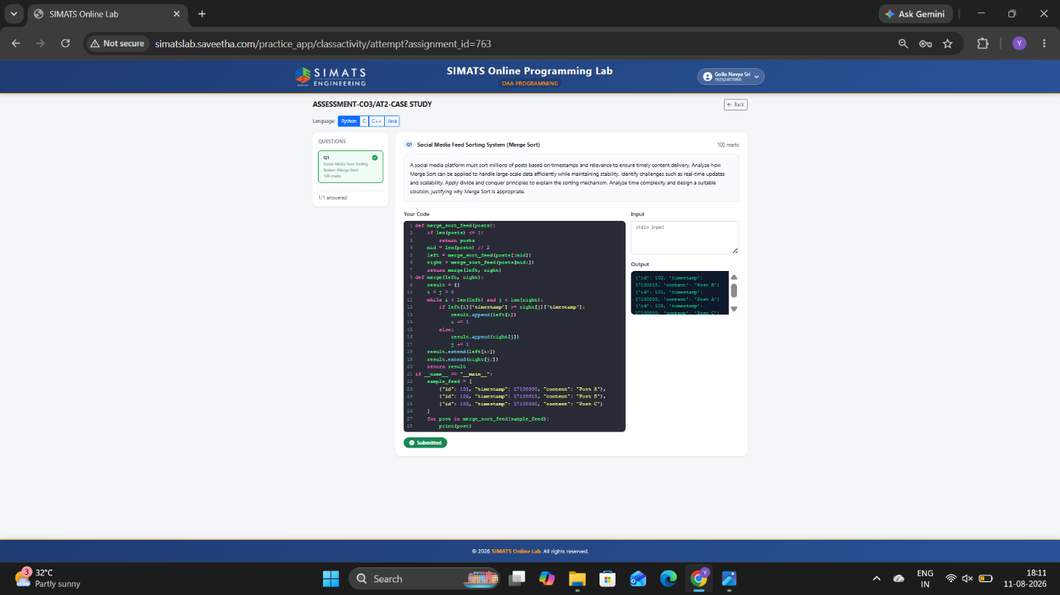
5. Clarity
- Merge Sort is appropriate because it is stable, predictable, and efficient for large datasets.
- Its O(n log n) time complexity allows millions of posts to be processed efficiently.
- The divide-and-conquer mechanism makes the algorithm easy to implement and suitable for parallel and distributed processing.
- Although real-time updates and memory requirements are challenges, batching, caching, incremental updates, and distributed Merge Sort can address them.
- Therefore, Merge Sort provides a reliable solution for large-scale social media post sorting while maintaining stability and scalability.

